# RECIPE SHARING WEBSITE

### A MINI PROJECTREPORT

#### Submitted by

#### Group/Team No: G21-A/T2

**NAME OF THE STUDENT1: HARSAINYAM SINGH**

**ROLLNO: 2310991840**

**NAME OF THE STUDENT2: HARSHDEEP SINGH**

**ROLLNO: 2310991841**

**NAME OF THE STUDENT3:**

**HARSHDEEP SINGH**

**ROLLNO: 2310991842**

#### in partial fulfillment for the award of the degree of

## BACHELEOR OF ENGINEERING

***in***

COMPUTER SCIENCE & ENGINEERING

**CHITKARA UNIVERSITY**

**CHANDIGARH-PATIALA NATIONAL HIGHWAY**

**RAJPURA (PATIALA) PUNJAB-140401 (INDIA)**

###### TABLE OF CONTENTS

###### 

|  |  |  |
| --- | --- | --- |
| **Sno.** | **Section** | **Page No.** |
| 1 | **Introduction** | 3 |
| 2 | **Problem Statement** | 4 |
| 3 | **Technical Details** | 5-7 |
| 4 | **Key Features** | 8-9 |
| 5 | **Bonus Features** | 10 |
| 6 | **Conclusion** | 14 |

INTRODUCTION

Welcome to Foodzee! Here, you can find and share all sorts of delicious recipes. It doesn't matter if you're experienced or just starting out in the kitchen – everyone is welcome. Explore a wide variety of recipes, connect with other food lovers, and enjoy the fun of cooking and sharing your favorite dishes.

Get ready to discover new flavors and recipes from around the world, all in one place! Our recipe sharing platform is designed to make cooking and sharing recipes as easy as possible.

User can Connect with fellow food enthusiasts, share your creations, and exchange tips and tricks. You can leave comments, rate recipes, and can even create your own video recipes and upload them.

Our website Provides a user-friendly and easy to navigate interface. Search for recipes, filter by ingredients, or explore trending dishes with just a few clicks. With just a click of button people can view food news get know more about new recipes and about foods to maintain their health.Created as a university project,Foodzee is a blend of HTML,CSS and JavaScript

This Recipe Provides a better medium and environment to Share all your recipes comments and Thoughts about a Recipe. People can share Recipes Through Text and videos As they like. People can get a generated recipe from The Ingredients They want so That people can enjoy Every Single bite of food .Overall Recipe Sharing Website is a great Way to Share your feelings and recipes through comments and other things.

In this report, we're going to show you around FoodZee and explain why it's a breeze to use. Whether you're a cooking pro or just starting out, we want you to feel at home here. FoodZee is a place where we can all come together and have fun with cooking.

PROBLEM STATEMENT

People often struggle to find and share recipes in a convenient way. This makes it hard to try new dishes, connect with others who love cooking, and keep their kitchen organized. Many food lovers struggle with the hassle of finding recipes that suit their tastes and dietary preferences, organizing their favorite dishes in one place, and easily sharing their culinary creations with friends and family.

This lack of an efficient and user-friendly recipe sharing platform limits their ability to explore diverse cuisines, learn from others, and make the most of their cooking experience. On internet Finding recipes is as difficult as finding needle in a haystack. There aren’t many stable platform to share all recipes whether it is video recipes or written recipes. Out there are not many recipe generators which give you recipes based on user given ingredients.

We want to make this easier for the users to share recipes online, and we accepted this challenge to find a way to simplify recipe sharing online, making it accessible to everybody and everyone.

TECHNICAL DETAILS

FRONT END -:

* HTML(Hypertext Markup Language)-: HTML is the base of our main website .It is Used to make the structure of a website which include different tags.
* HTML5-: Html5 is just html but with added features such as audio video support.



* CSS(Cascading style sheet)-**:**  Css is used for styling our structure made by HTML, such as adding colors , styles, animations and much more.



RESPONSIVE DESIGN-:

To make sure that our website is working on every single device responsive web design methods were used. Because of these methods our website can adapt to desktop, tablet, mobile phones laptops etc.

INTERACTIVE USER INTERFACE-:

Our user interface was designed with user experience in mind.This includes user friendly recipe sharing forms for recipe submission and search function to make it easy to find recipes. There are much more interactive things on our website to make sure user enjoys each and every moment on our website.

FILE ORGANISATION-:

Files of our website were organized into different categories , and maintained properly by adding different files into different folders so that it is easy to modify or change the content of our website.

HYPERLINKS AND NAVIGATION-:

All Hyperlinks and navigation were created in html to help user navigate through different pages. Proper link structures ensures a smooth browsing experience.

BROWSER COMPATIBILTY-:

FoodZee was tested in various web browsers (e.g., Chrome, Firefox, Safari, and Edge) to ensure it functions correctly and looks good across the board.

**BOOTSTRAP:**

1. **Introduction to Bootstrap:**
   * Bootstrap as a Web Development Toolbox
   * Streamlining Design with Pre-designed Components
2. **Key Features of Bootstrap:**
   * Responsive Design for All Devices
   * Time and Effort Saving with Ready-to-Use Components
3. **Functionality of Bootstrap:**
   * Components like Buttons, Forms, Navigation Bars
   * Ensuring Consistent and Appealing Design Across Devices
4. **Metaphor:**
   * Bootstrap as a Helpful Friend in Web Design

**JAVASCRIPT:**

1. **Introduction to JavaScript:**
   * JavaScript as the Dynamic Language for Web Interaction
   * Enhancing Websites with Real-Time Functionality
2. **Purpose of JavaScript:**
   * Creating Interactive and Engaging Web Experiences
   * Adding Life to Otherwise Static Websites\
3. **Capabilities of JavaScript:**
   * Pop-ups and Modal Windows
   * Content Updates Without Page Refresh
4. **Metaphor:**
   * JavaScript as the Spice That Elevates the Website Flavor

**HTML Structure:**

1. **Document Type Declaration (<!DOCTYPE html>):**
   * Specifies the document type and version of HTML.
2. **HTML Root Element (<html>):**
   * The root element that contains the entire HTML document.
3. **Head Section (<head>):**
   * Contains meta-information about the HTML document.
   * Meta tags for character set and viewport settings.
   * Link to the Bootstrap CSS file.
4. **Body Section (<body>):**
   * Contains the content of the HTML document.
5. **Navbar (<nav>):**
   * Bootstrap's navigation bar with a brand logo and navigation links.
6. **Main Container (<div class="container">):**
   * Bootstrap container for centralizing content.
   * Contains the main content of the page.
7. **Heading and Form (<h2>, <form>):**
   * Heading for the page.
   * Form for submitting reviews with input fields for name, comment, and hidden input for rating.
8. **Rating Buttons Container (<div class="rating-btn-container">):**
   * Container for rating buttons (1 to 10).
9. **Review Container (<div class="review-container">):**
   * Container for displaying submitted reviews.
   * Uses a 3D flip effect with CSS animations.
10. **JavaScript Libraries (<script>):**
    * Links to jQuery, Popper.js, and Bootstrap JavaScript libraries.
11. **JavaScript Code (<script>):**
    * JavaScript code for dynamic star rating, pop-up notification, and submitting reviews.
    * Functions for setting ratings, submitting reviews, and animations.

**CSS Styling:**

1. **Global Styles:**
   * Styling for the body, background color, and default styles for various elements.
2. **Navbar Styles:**
   * Styling for the navigation bar, including background color, box shadow, and text alignment.
   * Brand logo with rounded corners.
3. **Container Styles:**
   * Styling for the main content container, including background color, padding, border radius, and box shadow.
4. **Review Container Styles:**
   * Styling for the container displaying reviews.
   * 3D flip effect using perspective and transform properties.
   * Animation for sliding in reviews.
5. **Rating Button Styles:**
   * Styling for the rating buttons, including background color, text color, padding, font size, and border radius.
   * Hover effect for changing background color.

**JavaScript Interactions:**

1. **Dynamic Star Rating**:
   * Creation of star elements dynamically.
   * Event listener for clicking on stars to set the rating.
2. **Submitting Reviews:**
   * Function to submit reviews.
   * Validation for ensuring name, comment, and rating are provided.
   * Creation of a new review element with a 3D flip effect.
3. **Rating Buttons Interaction:**
   * Functions for setting the rating when clicking on the rating buttons.
4. **Libraries:**
   * Use of jQuery, Popper.js, and Bootstrap JavaScript for enhanced functionality and styling.

**General Features of JavaScript:**

1. **Dynamic and Weakly Typed:**
   * JavaScript is dynamically typed, meaning variable types are determined at runtime.
   * It's weakly typed, allowing for flexibility but requiring careful consideration to prevent unexpected behaviors.
2. **Prototypal Inheritance:**
   * Objects in JavaScript inherit properties and behaviors directly from other objects, forming a prototype chain.
3. **Event-Driven and Asynchronous:**
   * JavaScript is event-driven, responding to user actions or system events.
   * It supports asynchronous programming through mechanisms like callbacks, Promises, and Async/Await.
4. **Cross-Platform:**
   * Originally designed for web browsers, JavaScript is now used on various platforms, including server-side development (Node.js).
5. **Functional Programming:**
   * Supports functional programming concepts, such as first-class functions and higher-order functions.
6. **DOM Manipulation:**
   * JavaScript is often used to manipulate the Document Object Model (DOM) in web browsers, allowing dynamic updates to webpage content.
7. **Client-Side Validation:**
   * Used for client-side form validation to improve user experience and reduce server requests.
8. **Frameworks and Libraries:**
   * Numerous frameworks and libraries (e.g., React, Angular, Vue) built on JavaScript simplify and enhance web development.

**JavaScript in the Provided Website:**

1. **Dynamic Star Rating:**
   * JavaScript dynamically creates and handles stars for the rating system.
   * Event listeners capture user clicks on stars, allowing for interactive rating selection.
2. **Form Submission:**
   * JavaScript manages form submission, validating input fields (name, comment, rating).
   * Submits reviews, updates the UI with new review entries, and triggers animations.
3. **Animations:**
   * Utilizes JavaScript for creating animations (e.g., sliding in new reviews) to enhance user experience.
4. **Rating Buttons Interaction:**
   * JavaScript functions handle the interaction when the user clicks on rating buttons.
   * Updates the displayed rating and UI accordingly.
5. **Notification:**
   * JavaScript triggers a simple pop-up notification (using the **alert** function) upon submitting a review.

**Security Measures:**

Ensuring the security of user data is paramount in any web application. Our recipe-sharing

website implements various measures to protect user information, including email IDs,

passwords, and personal details. The use of encryption techniques, such as HTTPS, ensures

secure data transmission between the user's browser and the server. Passwords are hashed

using strong cryptographic algorithms, enhancing their protection against unauthorized

access. Additionally, stringent access controls and authentication mechanisms are in place to

safeguard sensitive user details.

**Database Implementation:**

Python serves as the backend language for our database, providing a robust and scalable

foundation for storing user information. The database securely stores user data, including

login details and passwords. Python's reliability and versatility contribute to efficient data

management, ensuring the confidentiality and integrity of user information. The use of proper

database security practices, such as parameterized queries, helps prevent common security

vulnerabilities like SQL injection. Overall, our database implementation prioritizes data

security, creating a trustworthy environment for users to engage with the recipe-sharing

platform.

KEY FEATURES

USER ACCOUNT AND LOGIN/SIGNUP-:

This feature allows user to create an account for itself and can use that account to store information. Account helps users to keep record of things they are doing. User can directly create an account by Signup feature or directly login into his/her existing account with login feature.

RECIPE SUBMISSION AND FILTER-:

By using this user will be able to submit their written recipes for other users to see and review .This also allows user to upload images of the dish. Filter feature adds an interactive yet easier method to filter through a variety of recipes . User can filter recipe type their difficulty level and dietary preferences.

**VIDEO RECIPES-:**

Now Users can not share written recipes but video recipes as well. They can teach each other different recipes through videos and these video will be available in different quality options such as 144P, 240P, 360P, 720P and 1080P. Users can Provide Captions in their video if they don’t understand the speaking language.

**RECIPE RATINGS AND COMMENTS-:**

User can now rate the recipes submitted and uploaded by other users by star rating system and help other users to make a difference between two recipes of same kind. Comments section will help users to interact with each other and share information about recipes.

**FAVOURITE SECTION-:**

People can now add a written or video recipe to favorites section to view them later or make the recipe their favorites. This feature is essential to help people differentiate their favorite recipe from normal recipe.

**USER NOTIFICATION AND SOCIAL MEDIA SHARING-:**

While people do other work , they can get notifications about their accounts , comments on their recipe and how much people liked their recipe directly on their device notification section. User can Share the Recipe if they like to any platform from our website. They can refer links for video recipe and short texts for written recipe.

**RECIPE GENERATOR-:**

User can get a Generated Recipe from the ingredients they like. This page as input fields which allows user to enter the ingredients and in result they a generated recipe. This recipe generator will help a lot of people who have leftover ingredients and don’t know what to do with them.

**PROJECT ADVANTAGES**

RECIPE KNOWLEDE SHARING-:

This website provides a platform to share a knowledge about different recipes , cooking tips. Dietary preferences. This encourages a sense of sharing and learning. Users can learn new cooking techniques, experiment with different cuisines, and enhance their culinary skills by trying out recipes from the platform.

USER ENGAGEMENT-:

Recipe-sharing websites often have high user engagement, as users interact through comments, likes, and sharing. This can lead to a sense of community and social interaction.

RESUME AND PORTFOLIO BUILDER-:

Creating and managing such a website is a valuable addition to your portfolio as a web developer or designer. It showcases your skills in HTML and CSS.The project can serve as a starting point for future development. You can continue to add features, improve user experience, and possibly even monetize the website through ads or premium content.

ACADEMIC ACHIEVEMENT-:

Successfully completing this project demonstrates your ability to conceptualize, design, and develop a web application, which can be a significant achievement in your academic career.

BONUS FEATURES

**VIDEO RECIPES-:**

Now Users can not share written recipes but video recipes as well. They can teach each other different recipes through videos and these video will be available in different quality options such as 144P, 240P, 360P, 720P and 1080P. Users can Provide Captions in their video if they don’t understand the speaking language.

**FAVOURITE SECTION-:**

People can now add a written or video recipe to favorites section to view them later or make the recipe their favorites. This feature is essential to help people differentiate their favorite recipe from normal recipe.

**ADVANCED SEARCH FILTERS-:**

Enhance the search functionality with filters for seasonality, cost, and specific dietary requirements. Filter feature adds an interactive yet easier method to filter through a variety of recipes . User can filter recipe type their difficulty level and dietary preferences.

**SUBSCRIPTION OR PREMIUM MEMBERSHIP-:**

Offer a premium membership with additional features, such as ad-free browsing, exclusive recipes, or early access to content.

**RECIPE GENERATOR-:**

User can get a Generated Recipe from the ingredients they like. This page as input fields which allows user to enter the ingredients and in result they a generated recipe. This recipe generator will help a lot of people who have leftover ingredients and don’t know what to do with them.

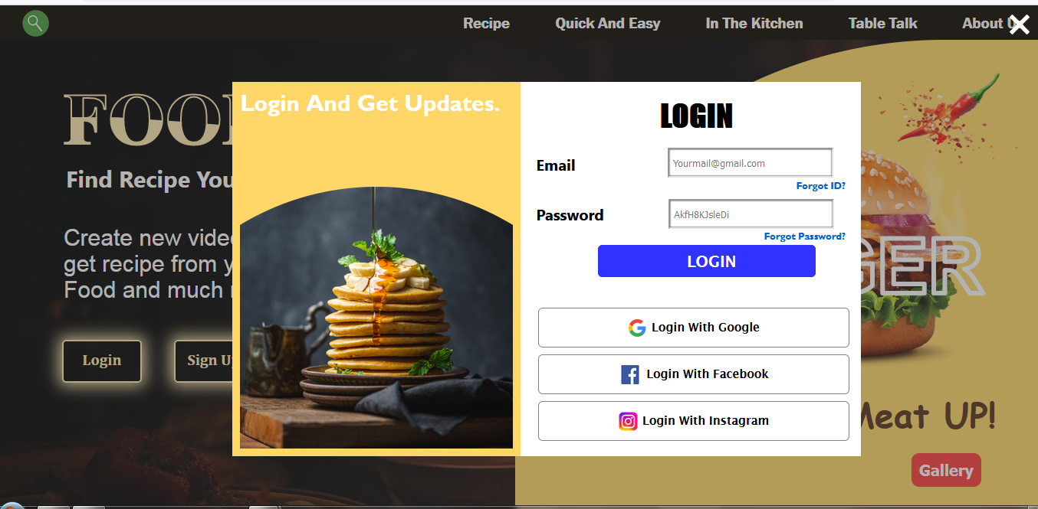

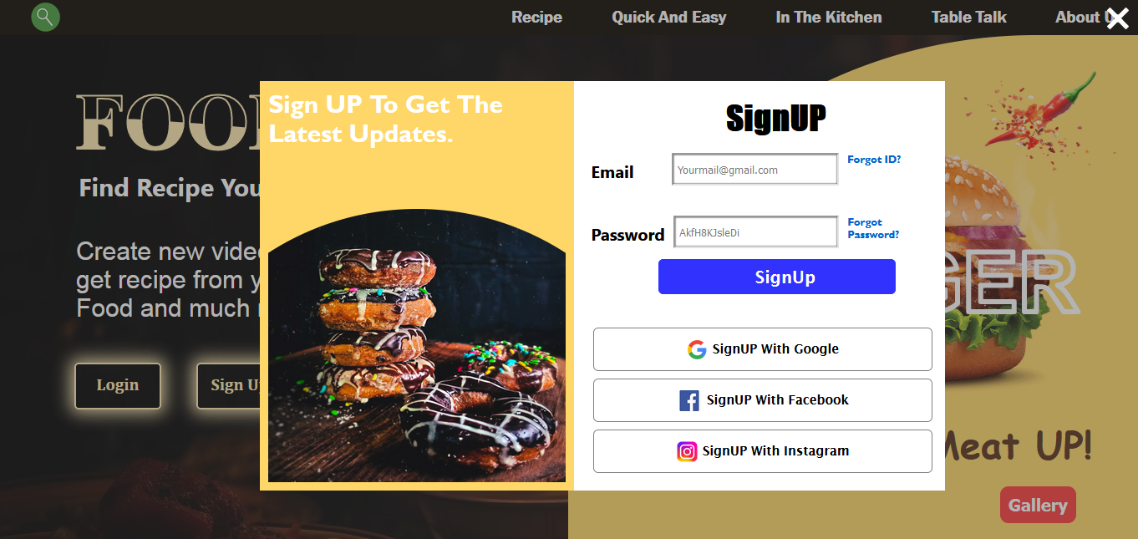

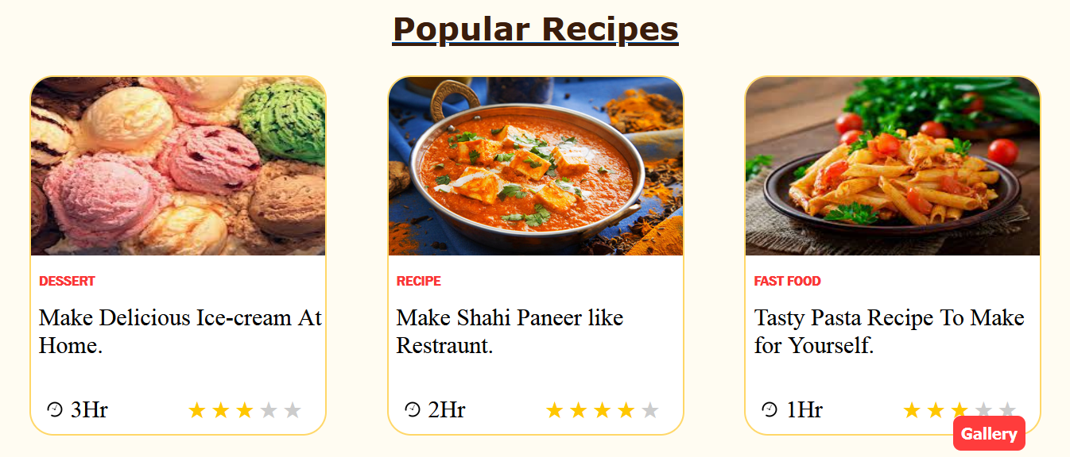

CONCLUSION

In conclusion, a recipe sharing platform website provides a valuable space for culinary enthusiasts to come together, exchange ideas, and explore the rich world of food. It fosters a sense of community, encourages creativity in the kitchen, and allows individuals to discover and share their favorite dishes with a global audience.

As we've discussed, these platforms offer a wide range of benefits, from diverse recipe collections to interactive features like comments and ratings, making them a hub for food lovers everywhere. Whether you're a seasoned chef or a novice cook, recipe sharing websites offer an engaging and enriching experience that brings people closer through the universal language of food. So, join in, share your culinary creations, and savor the delicious journey of exploring new flavors and cuisines with the global recipe-sharing community.

Moreover, the project offers the opportunity to showcase our web development and design skills, making it a valuable addition to our portfolio. It also provides insights into user behavior, which can guide future enhancements. The potential for expansion, monetization, and collaboration adds a layer of excitement and growth prospects.

**LIST OF REFERENCES**

**W3 SCHOOLS-:** [**https://www.w3schools.com/**](https://www.w3schools.com/)

**GOOGLE-:** [**https://www.google.com/**](https://www.google.com/)

**SIMPLY RECIPES-:** [**https://www.simplyrecipes.com/**](https://www.simplyrecipes.com/)

**BENNETTFEELY-:** [**https://bennettfeely.com/clippy/**](https://bennettfeely.com/clippy/)